SUBSCRIBE GOLORE: EXPERIENCE WORLD TOP YOUTUBE CHANNEL’S

**INTRODUCTION**

**Subscriber to a channel on the video-sharing YouTube is a user who has chosen To receive the channel’s content by clicking on that channel’s “Subscribe” button,And each user’s subscription feed consists of videos published by channels to which The usHuer is subscribed. The ability to subscribe to users was introduced in October 2005. YouTube began publishing a list of its most-subscribed channels in April 2006.**

**An early archive of the list dates to May 2006 The following table lists the 50 most-subscribed YouTube channels, as well as the Primary language and content category of each channel. The channels are ordered By number of subscribers; those whose displayed subscriber counts are identical Are listed so that the channel whose current growth rate indicates that its displayed Subscriber count will exceed that of the other channel is listed first.**

**Problem definition and design thinking**

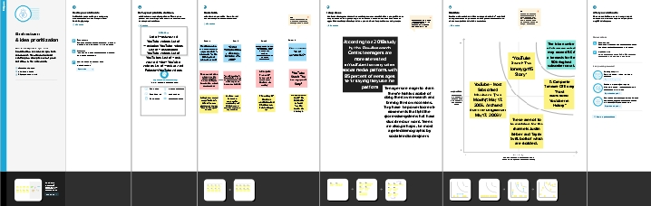

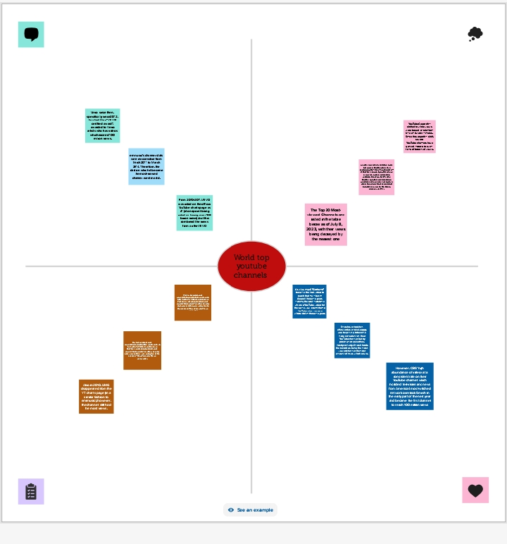

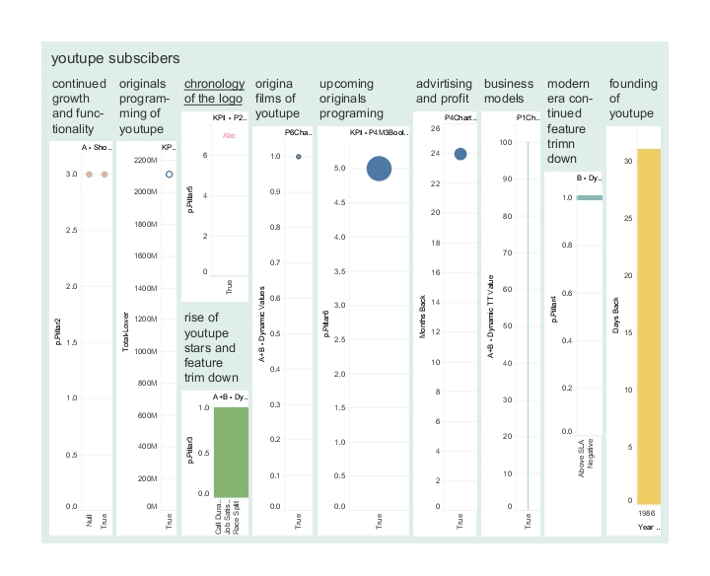**Advantage**

**You can use YouTube for learning. Youtube is a platform for learners. You can learn anything from anyone, be it a chef or an expert, everything is accessible on youtube**

**Starting a YouTube channel gives your audience access to more of your content. If you already use video marketing in your marketing strategy, a YouTube channel gives you a centralized location to post advertisements, informational content and entertainment videos.**

**Disadvantage**

**Obscenity- one of the biggest drawbacks that YouTube has**

Since YouTube is a no-cost and accessible platform for anyone, children are attracted to watching videos with explicit language and obscenity.

There’s inappropriate content all over the site

**Application**

**Data collection is the process of gathering and measuring information on variables Of interest, in an established systematic fashion that enables one to answer stated Research questions, test hypotheses, and evaluate outcomes and generate insights From the data.**

**Conclusion**

**Data visualization is the process of creating graphical representations of data in**Order to help people understand and explore the information. The goal of data Visualization is to make complex data sets more accessible, intuitive, and easier to Interpret. By using visual elements such as charts, graphs, and maps, data Visualizations can help people quickly identify patterns, trends, and outliers in the

**Future scope**

**YouTube is an online video sharing and social media platform headquartered in San Bruno, California, United States. Accessible worldwide,[7] it was launched on February 14, 2005, by Steve Chen, Chad Hurley, and Jawed Karim. It is owned by Google and is the second most visited website in the world, after Google Search. YouTube has more than 2.5 billion monthly users,[8] who collectively watch more than one billion hours of videos every day.[9] As of May 2019, videos were being uploaded to the platform at a rate of more than 500 hours of content per minute.**

**APENTIX**

The appendix (pl: appendices or appendixes; also vermiform appendix; cecal [or caecal] appendix; vermix; or vermiform process) is a finger-like, blind-ended tube connected to the cecum, from which it develops in the embryo. The cecum is a pouch-like structure of the large intestine, located at the junction of the small and the large intestines. The term “vermiform” comes from Latin and means “worm-shaped”. The appendix was once considered a vestigial organ, but this view has changed since the early 2000s.[1][2] Research suggests that the appendix may serve an important purpose as a reservoir for beneficial gut bacteria